Plan for the orchard.
September light summer prune of the apple trees.
Strim around the trees, clear grass and put chip bark around the trunks. Keep guards.
Remove striping beef tree that has died. (No. 5 on the diagram)
Plant a new heritage tree, to replace the striping beef, in the new cleared area.
When the leaves have fallen off the hazel trees, coppice the trees to create more light
Water regularly new tree.
Add a ‘secret’ gate, to allow easy access to the water supply

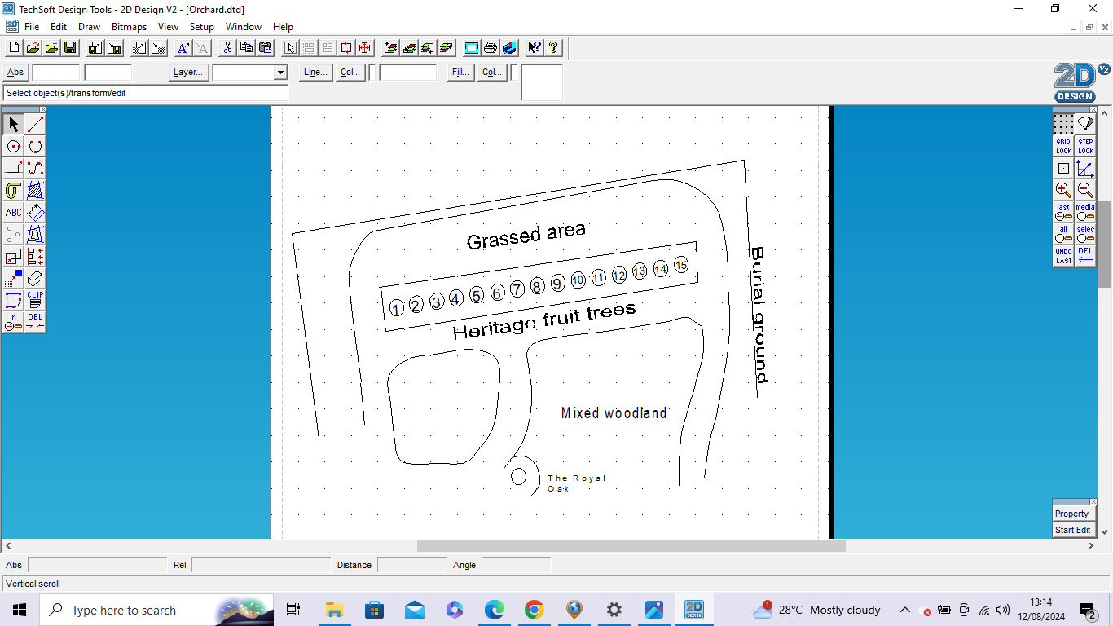
Coppice the hazel trees. Look to harvest the branches.
Clear the corner wild area.

Full winter prune.
Purchase a replacement tree for the Striped Beefing. Possibly Dewdney’s Seedling, a red cooker. It’s of Lincolnshire origin and is in the same pollination group as at least Schoolmaster which is also in the orchard.

