Nettleham Parish Council Biodiversity Strategy

Proposed Actions for Biodiversity
Councils are required to complete their first consideration of what action to take for biodiversity by 1 January 2024 and agree policies and objectives as soon as possible afterwards (see government guidance and SLCC | New Government Guidance on Biodiversity). Local authorities (excluding parish councils) and local planning authorities must write and publish a biodiversity report. Other public authorities must fulfil their duty, but do not need to publish a report.

This document sets out actions that Nettleham Parish Council (NPC) can take to meet their duties regarding conserving biodiversity.
Background

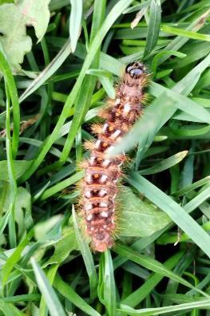
Under the Natural Environment and Rural Communities Act 2006 there is a duty on public authorities in England, including Parish Councils to have regard to conserving biodiversity as part of their policy or decision making. This was further strengthened by the Environment Act 2021 so public authorities must now consider what they can do to conserve and enhance biodiversity in England. This means a public authority must;
- Consider what they can do to conserve and enhance biodiversity.
- Agree policies and specific objectives based on their consideration.
- Act to deliver policies and achieve objectives .

Biodiversity refers to the variety of life on earth. All life forms have evolved to find their place in an ecosystem, whether at the top of the food chain as a predator, or at the bottom as insects or micro-organisms, plant or fungus.
Underpinning all this is availability of clean air, water and healthy soils, and the space to thrive and connect.
Overview
To conserve biodiversity we need to:

Figure 1 Caterpillar, Mulsanne Park

- identify a baseline metric for biodiversity in Nettleham Parish (Nettleham village, Minster Fields and other areas within the parish owned/managed by NPC);
- identify those areas and actions over which NPC has influence;
- assess any potential harms and mitigations;
- identify what measures can be implemented to enhance the natural environment; and
- identify where there is potential for increasing biodiversity.
We should involve local expertise and seek advice from bodies such as Natural England, Environment Agency, Forestry Commission, local wildlife trusts or consultant ecologists as appropriate.
Conserving biodiversity is not a one-off exercise but an ongoing process.
Duties

Nettleham Parish Council will need to be mindful of how its strategies comply with the following:
- Local Nature Recovery Strategies^{i} (LNRS)
- Species Conservation Strategies^{ii}
- Protected site strategies^{iii}

We will need to understand how these strategies affect land that we own or manage, or actions we could take to conserve and enhance biodiversity.

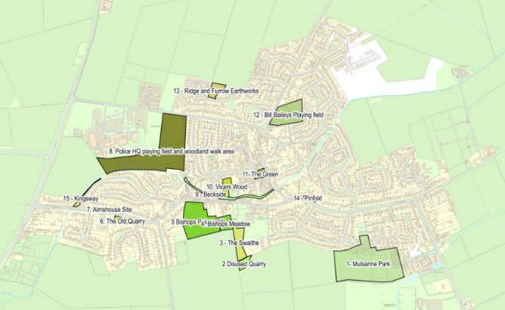
Actions for Nettleham PC
With reference to habitat designations shown on Defra’s Magic Map and working with the Greater Lincolnshire Local Nature Recovery Strategy (GLLNRS) we will produce a Local Habitat Map showing areas of existing good habitat for wildlife, and areas of opportunity to recover nature that also provide wider benefits e.g. natural flood management.

The figures show the green spaces within Nettleham village and at Minster Fields that should have protection from development provided by the Nettleham Neighbourhood Plan (once adopted).

Figure 2 Nettleham Green Spaces (from Neighbourhood Plan)

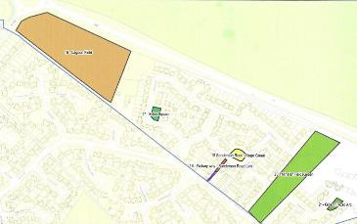
Figure 3 Minster Fields
We will identify any other areas in the Parish where at risk species and/or sites can be protected or enhanced.
This will require an assessment of the current status of biodiversity in the Parish. It is recommended that a robust ecological survey is conducted to provide a baseline against which improvements in biodiversity can be measured.

Any development work in the parish must have regard to monitoring impacts on biodiversity and identification of ways of increasing it.
Developers will by 2024 have to deliver a minimum of 10% Biodiversity Net Gain^{iv} (BNG) on projects as defined by Government. While this might not be a statutory requirement, NPC should aspire to 10% BNG as a minimum on any project.
The impacts on biodiversity in decisions made through the PC should be considered, especially when commenting on planning applications.
When we carry out maintenance work we should aim to minimise disturbance to wildlife, and consider whether we can reduce the use of energy and water to help reduce pollution and address the pressure it puts on wildlife.
A range of specific actions can be taken to suit particular circumstances, for example:

Reduce and/or eliminate the use of pesticides and herbicides on council property
  - allotments
  - cemeteries
  - parks and sports fields
  - amenity spaces and communal gardens
  - roadside verges
  - field margins and hedgerows
  - rights of way and access routes
  - woodlands

  - beckside
  - water-dependent habitats

Extend ‘No Mow May’
We should extend ‘No-mow May’ both in season, i.e. to September and in the number of areas in the parish where no mowing should apply. This will have cost savings for the parish. This is likely to require some management of public expectations, and education about the benefits. Some residents may not appreciate that there is likely to be a less ‘tidy’ look to the village.
We will need to work with residents to identify where it is applicable to reduce mowing of verges and enhance with wildflowers.

Encourage residents and community groups, including schools to embrace biodiversity
We should seek to educate the public on the benefits of biodiversity and encourage practical actions such as:
- Making their gardens more wildlife friendly (making space for nature, creating bee hotels, woodpiles, leaving access for hedgehogs in fences and walls, not laying artificial grass, leaving grass long, planting wildflowers)
- Create wildlife ponds
- Gardening organically (eliminating herbicides and pesticides)
- Use of water butts to conserve water
- Control of dogs and cats, raising awareness of their potential for damage to habitat and species

Encourage local businesses, suppliers, farmers and contractors to embrace biodiversity
We should assess suppliers to the council on their approach to biodiversity, and encourage practices that have benefits. We should work with local businesses to raise awareness to encourage practices which benefit biodiversity. For example;
- Suppliers of flowers/hanging baskets (e.g. use of peat, pesticides, native flora)
- Suppliers of cleaning materials (biodegradable, ecologically friendly)
- Sourcing of products from suppliers whose businesses do not impact negatively on biodiversity, for example

Protection of Clean Air and Water
- We should protect Nettleham Beck as far as practicable from pollution. The use of pesticides and fertilisers by neighbours should be discouraged.
- We should address engine idling (including buses, delivery vans) and traffic congestion.
- We should maintain SUDs schemes where these exist in the parish

Habitat Protection/Green Corridors
- We should seek to ensure that all green areas have connectivity, by additional planting of trees and hedgerows where applicable.
  - using native and sustainably sourced trees when planting
  - leaving dead wood safely in place in woodlands to provide additional habitat
  - maintaining planted trees to give them the best chance of survival
  - reducing the use of herbicides, pesticides, peat and water
  - implementing measures to prevent the spread of invasive species and plant disease
  - any tree and hedge cutting to be undertaken outside of bird nesting season
  - not permit any netting of habitats to prevent bird nesting

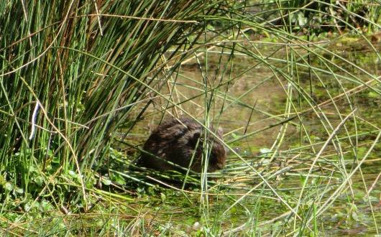
Create new habitat and space for nature

On NPC property, where appropriate we could:
  - build and install nest boxes for birds, bats and other animals
  - add green walls or roofs to existing or new buildings
  - plant native trees and shrubs
  - plant wildflowers for pollinators

Educate, advise and raise awareness

Figure 4 Water Vole, Nettleham Beck May 2020

We can help the public understand biodiversity and why it’s important to conserve and enhance it.
We will need to:
  - include the public in projects to improve biodiversity
  - feature biodiversity in public or internal communications
  - use libraries and local magazine to raise awareness of biodiversity
  - put information boards in green spaces
  - offer guided walks
  - include biodiversity considerations in advice for internal and external clients and service users
  - educate staff on our biodiversity actions and why they are important

Review internal policies and processes
NPC should work towards:
  - the use of sustainable materials and supplies to reduce the demand on natural resources
  - light – make sure the design of artificial lighting minimises effects on nature

Sources of further information and support:

Greater Lincolnshire Nature Partnership
Banovallum House Manor House Street Horncastle
Lincolnshire
LN9 5HFTelephone01507 526667 Websitehttp://www.glnp.org.uk

Natural England has published the Green Infrastructure Framework - Principles and Standards for England. This includes planning, design and process guides.

i The Local Nature Recovery Strategies are currently being developed in Lincolnshire by a partnership of all the Lincolnshire councils with support and guidance from Natural England. The Greater Lincolnshire LNRS (GLLNRS) will describe Greater Lincolnshire and its biodiversity, will identify local people's priorities and potential opportunities for recovering or improving biodiversity, and:

- Map areas of existing good habitat.
- Identify local priorities and ways to achieve these.
- Map the best areas to achieve these priorities and provide wider environmental benefits.

^{ii} Established by the Environment Act 2021, species conservation strategies aim to safeguard the future of the species that are at greatest risk. The strategies will find better ways to comply with existing legal obligations to protect species at risk and to improve their conservation status.

iii Established by the Environment Act 2021, protected site strategies take a new approach to protecting and restoring species and habitats in protected sites. Protected site strategies will provide ways to overcome offsite pressures such as nutrient pollution in the wider catchment.

^{iv} Biodiversity net gain (BNG) is an approach to development or land management that aims to leave the natural environment in a measurably better state than it was beforehand.

Adopted 21/11/23

Reveiw Due: As required / following changes to relevent legislation.

