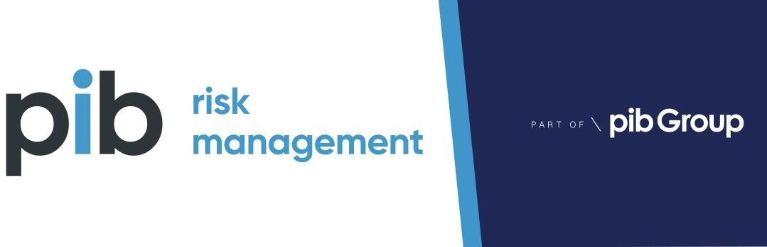

Health & Safety Audit
of
Nettleham Parish Council

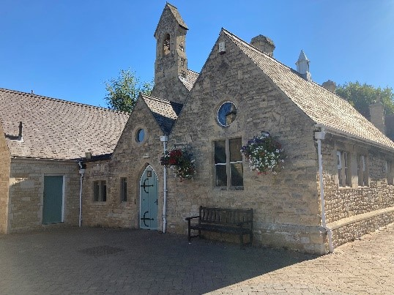
Former Police Office Scothern Rd, Nettleham,
Lincoln LN2 2TU

Auditor : Peter Higton Dip NCRQ Date: 15 June 2023

Introduction

  - A Health & Safety audit of Nettleham Parish Council was carried out on 15 June 2023 hosted by the Facilities Manager Jane Ashby.

  - The council currently has 5 direct employees, with one full time and the remainder part time. The workforce includes the Parish Clerk, Accounts Assistant, Assistant Clerk, Facilities Manager, and Village Handy Person.

  - There are no members of staff with mobility issues or known health issues.

  - The premises are council owned and within Nettleham parish on the outskirts of Lincoln, with the exception of the Parish Office which is leased from Lincolnshire Police. There are four buildings in total, the Old Police Office, Mulsanne Pavilion / Sports Ground and The Old School which comprises of the small and large halls. All facilities have parking adjacent to the premises.

Policy and Organisation for Health and Safety

  - A H&S Policy is in place which was prepared initially in 2017 by PIB Risk and has been reviewed annually since. The H&S policy is to be reviewed by PIBRM. The H&S policy is to be reviewed in June 2023 (desk top exercise) and will be sent to the Facilities Manager upon completion.

  - New employees receive an induction to council policy and procedures which is recorded on an induction form. Induction records are kept up to date as & when required. New employee Lucy Waller has since joined the team this year and has been suitably inducted 27 March 2023.

Arrangements for Health and Safety

  - The arrangements for management of health and safety are reflected within the H&S Policy and Council procedures. General arrangements were discussed as below:

  - Asbestos – All buildings have had an Asbestos Management Survey completed and any recommendations made have been closed out with ongoing monitoring in place. Asbestos is monitored and appropriate information disseminated to any contractors required to carry out any building/maintenance work.

The Mulsanne Pavilion has areas of asbestos identified with appropriate labelling. Some areas within the changing rooms had been damaged previously and a local Asbestos company (Rilmac) was called in to

appropriately remediate these areas (via encapsulation) this work has now been completed satisfactorily and the asbestos register has been updated accordingly to reflect this.
Prior to undertaking any minor maintenance work within premises, a copy of the Asbestos Management Plan should be checked to ensure employees, contractors or sub-contractors do not inadvertently disturb any encapsulated asbestos. Work with Asbestos can only be undertaken by persons with suitable training (i.e. UKATA Cat B Training minimum).

Any major refurbishment work will require a full ‘refurbishment and
demolition asbestos survey’ to be conducted which is intrusive and covers all areas.

It was previously recommended that the Facilities Manager and Village Handy Person undertake an Asbestos Awareness Training course, so they can easily identify any potential Asbestos Containing Materials. Suitable asbestos awareness training has now been carried out by the Facilities Manager and the Village Handy Person by PIB (on accredited UKATA course).

Facilities manager Jane Ashby & Village handy person Kev Pyrah have undertaken suitable asbestos awareness training on December 15th 2022.

  - Health surveillance is not currently undertaken nor deemed to be relevant with the current scope of works.

The main health risks include manual handling and use of some hazardous substances for maintenance and cleaning purposes but these are infrequent and short duration only.

An open-door communication policy exists where any health issues are discussed with the Parish Clerk or Facilities Manager. If necessary, then an Occupational Health Company will be contacted for further advice.

  - Work equipment includes Class 1 and 3 ladders, battery drills, spades, strimmers, hand tools, and barrows / trolleys etc. The majority of equipment is council owned however some belong to the Village Handy Person but the Facilities Manager confirmed that this is unusual but ensure that any electrical items used are PA Tested along with owned equipment.

Regular maintenance, servicing and inspections are undertaken as required with records held in the office. Pre-use checks are undertaken as part of the procedures and the Facilities Manager and Village Handy Person have a good level of awareness. Any issues or defects found are reported back to the Facilities Manager and dealt with. A simple daily check sheet for power tools has been discussed which the Facilities Manager is going to arrange moving forward.

Personal Protective Equipment (PPE) is provided to employees free of charge and exchanged as required. The Village Handy Person has a dedicated storage area within the workshop at the Old school for PPE. The Facilities Manager also confirmed that in addition, waterproofs have been provided since the last audit.
  - PAT testing for office and building equipment is undertaken on an annual basis by an external contractor with records kept. The testing was last undertaken in November 2022 and the Facilities Manager has this noted on her calendar of servicing to book in again for later this year.

  - COSHH Assessments have been undertaken for hazardous substances although they are generally limited to cleaning chemicals, and a few mechanical related substances in the workshop store. These should be formally reviewed annually to check the Material Safety Data Sheets have not changed (MSDS).
Cleaning is undertaken by a contract cleaning company (Sweep Clean Commercial), so they are responsible for doing their own risk assessments.

The Village Handy Person has a bunded store for hazardous substances and a specific flammables cabinet (external to the workshop).

  - Legionella – There is a tank fed water system in place at the Mulsanne Pavilion, the showers are run weekly as part of the weekly checklist and regular water temperature checks are undertaken and recorded. The Facilities Manager attended a course in 2018 on the control of Legionella so is competent in this area. The facilities manager Jane Ashby has been on a current legionella awareness course on 11 November 2022 following last year’s audit recommendation.

A specialist water hygiene contractor (Second Element) is contracted now to undertake Legionella risk assessments and inspections on an annual basis (the last visit was March 2023) and has been completed appropriately with records held in the Parish office.

  - Manual handling is avoided or at least minimised wherever possible. Risk assessments have been undertaken for generic movement of equipment and barrows / trolleys are available for use when moving heavy or larger items (i.e. chairs / ladders).
Manual handling risk assessment review is due next month (July) which will be carried out by the facilities manager.

Formal manual handling training has been undertaken now by both the Facilities Manager and the Village Handy Person (11 Nov 2022) – it is now recommended that manual handling awareness refresher training is maintained.

There is a good level of signage in place within the various premises to advise of the required stacking levels for furniture and how to safely move them, this is also covered within the terms of hire. New tables have recently been sourced and most of these have wheels to reduce manual handling even further.

  - First aid training (EFAW) has been undertaken by the Facilities Manager in March 2022, with the Assistant Clerk having also now undertaken the EFAW course in June 2022 to ensure that cover is maintained should either be away on holiday or for absence.

Each building has a first aid kit situated in a prominent position. They are regularly checked (monthly and recorded in the premises check sheet) and re- stocked by the Facilities Manager.

  - Fire risk assessments have been completed for each building (completed by Jane Ashby) – there were no issues highlighted. These should be reviewed every year to ensure they remain up-to-date and relevant. The Facilities Manager has recently reviewed the FRA (August 2022) with no issues being noted.

A sample of fire extinguishers in each of the buildings were checked and found to have appropriate inspection dates. All were last serviced in July 2022 by an external fire company and certificates are displayed within each building.

Firefighting equipment will be due annual inspection next month by Lindum fire services.

Fire inspections and checks are carried out by the Facilities Manager and log- book entries made. Fire checks include testing of alarm systems, emergency lighting, fire extinguishers and exits as a minimum.

A review of fire log books have highlighted a few areas for improvement – PIBRM has sent the facilities manager the latest PIB fire log book to assist in ensuring correct checks are suitably recorded.

Fire action signage has been put in place for Mulsanne Pavilion, stating action and muster points. Fire evacuation muster points were evident in other locations and information is provided to those who rent out the premises.

Fire alarms and smoke detectors are in place around each building, and it was noted that the Village Handy Person’s store / workshop also has a smoke detector following the fire risk assessment.
Fire Extinguisher refresher training is now required for the village handy person and Facilities Manager.

  - Work at height is generally only via ladders / step ladders. They are inspected on a monthly basis now with records kept. Visually they appeared in good working order on the day of the audit and are stored appropriately within the workshop or storage areas.

Online ladder training has been completed by those that use them (11th November 2022). This just needs refreshing every 3 years although the Facilities Manager confirmed that they are rarely used.

  - Lone Working: - The Facilities Manager and the Village Handy Person generally work alone across the parish buildings and external areas. They complete a morning check-in with each other and the Parish Clerk / Assistant Clerk. They also carry a mobile phone at all times in case of emergency and hours are limited so it is deemed that current control measures are suitable and sufficient.

Online lone working training was however undertaken by both in 11 November 2022 which is good to see.

Access to Competent General Health and Safety Advice

  - PIB Risk Management are the retained external Safety Advisers to Nettleham PC and will assist the Company in all areas of health and safety as required. This includes an annual audit and review of the company Safety Policy and documentation.

  - Advice will also be given on an as-required basis with any relevant updates communicated via Newsletters or direct emails / discussion.

Training

  - A training matrix is in place which is kept up to date. A previous recommendation was that it would be useful to have expiry dates of courses so that refresher training can be easily identified – this is an on-going item which is being improved as time progresses.
  - DSE assessments have been undertaken by all relevant staff, these just need a review every year to ensure they are still relevant, and it is understood that these will be due soon (August 2023).
  - Since the last visit training has been completed by facilities staff and can be observed and verified on the available training matrix.
  - The Facilities Manager and the Village Handy Person completed Play Equipment training back in May 2018 with refresher training carried out June 2022 to facilitate the management of playground equipment.

Monitoring, Audit and Review

  - PIB RM undertake an annual H&S audit of the premises and H&S related documentation relating to the Parish Council.

  - Weekly site inspections are completed by the Facilities Manager and recorded on a job sheet or specific form. These include RoSPA checklists for play equipment, routine premise inspections and weekly shower checks in the Pavilion (this includes the checking of the resident AED) and has been confirmed by the facilities manager with records on-line and in FM manager diary.

  - Formal monthly premise inspections continue to be completed and recorded as required (and deemed good practise).

Consultation – Workforce Involvement

  - Nettleham PC operates an ‘open door’ policy regarding consultation and communication with employees.

  - Regular Parish Council meetings are currently held with notes taken and formally minuted. Health & safety matters can be discussed and closed out during these meetings.

  - Daily briefings take place between the Facilities Manager and the Village Handy Person to discuss the coming days work. This includes an element of H&S (i.e. any accidents or incidents and method statements etc. for contracted services).

Accident Reporting

  - Accident information is recorded in each premise within the accident book with pages removed as per the data protection act. The Facilities Manager checks these periodically when visiting the premises.
No Accidents/incidents/near misses reported since the last audit.

  - A near miss form is in place and the importance of gathering this information was discussed. It is clear that all employees are aware of the need to report any incidents however none have occurred in the last 12 months.

Control of Contractors

  - Nettleham PC currently use contracted services for cleaning and some maintenance activities.

  - They are asked for their public liability insurance and credentials, along with risk assessments and method statements during the tender process.

  - A Sub-contractor questionnaire in now in place and will be sent out to prospective contractors to check competence prior to engagement.

Risk Assessments Leading to a Safe Method of Work

  - Nettleham Parish Council have generic risk assessments in place which were compiled by PIB RM in 2019, these were then reviewed internally and made specific to the Parish Council which is very good practice. The Facilities Manager has reviewed last year (August 2022) and are now due review soon.

  - Following the review and update as required, they will be circulated to all staff for comment prior to being implemented. It would be useful to do this annually to ensure that all relevant tasks are covered and that the controls mentioned are still suitable.

  - Method statements are not currently compiled. It was noted however that for larger projects (where external contractors are engaged) they are requested by the Facilities Manager or for high risk work to agree a safe system of working.

Premises and Housekeeping

  - The premises were found to be in good order throughout all of the buildings with no issues raised which is really positive.

  - No smoking signs are displayed throughout the premises.

  - Lighting and ventilation were found to be good with a mixture of both artificial and natural methods available.

  - Access and egress within the premises was found to be generally good with floor / surfaces in good condition and doors kept clear (and this includes no obstructed fire doors/exits noted at the time of audit which is good to see).

  - Welfare facilities are provided in all premises and include toilets and kitchen areas along with seating. All aspects of welfare were noted as being in a clean and tidy condition and are clearly well maintained and monitored.

  - Storage areas were found to be in reasonable condition with items stored safely although there has been an increase in tables and chairs recently but nothing was found to be causing any real problems.

  - During a tour of the buildings under the remit of the facilities manager, it was confirmed that gas boiler servicing and fixed wire electrical testing are all in date, and that PAT on relevant appliances was also observed to be in date (carried out November 2022).

  - Whilst walking around the premises it was noted and highlighted that relevant insurance certificates were just out of date. As such the facilities manager subsequently proved that insurances were in date (certificates held on the electronic system) and that updated certificates will be displayed in the buildings under NPC remit.

Conclusions

  - This year’s audit has found that Nettleham Parish Council (NPC) continue to exercise their due diligence and duty of care for their employees and the wider public whom they serve. Documentation checked was found to be in very good order, and premises inspected found to be clean, tidy and in very good condition throughout.

A few minor issues were noted during the visit – namely insurance documents displayed were found to be out of date (insurance was in place and copies will be replaced with updated details very soon).

Further advice & guidance was given with respect to aspects of the fire log book – additional information has been supplied to the facilities manager to assist in this manner. It is anticipated that actions required will be easy to implement and at no cost moving forward as discussed at the time of visit (check list supplied for fire door checks).

Training continues to be undertaken as required and the facilities manager has a good working matrix to assist in the control of courses to be taken.

Fixed electrical wiring and gas checks as spot checked were found to be compliant and in date with no issues noted.

Overall this has been an excellent audit for NPC, with the minor points raised to be closed out in short order.

