Dear Jane,

Green Lane, Nettleham - tree survey
30th May 2023

Thank you for instructing me to carry out the tree survey for Green Lane, a public bridleway. Please find the accompanying report, map and invoice. •
The tree survey report primarily highlights the issues I have identified in relation to tree safety, and makes recommendations to mitigate the associated risk.
I have made comment in some cases where a tree has a feature of interest; for example is a remnant of old hedgerow management, or has an unusual form.
I did not find any tree that, in my opinion, presents a need for removal or further pruning.

The size ranges I use in the report:
S1 to Sm, S2 5-10m, S3 10-15m, S4 15-20m and S5 over 20m OHB's means overhanging branches
BW Bridleway

Many of the trees I inspected have dense ivy growing up the stems and into the crowns. Ivy in mature trees has two impacts of note; dense ivy hides any obvious stem defects, such as cavities, and it increases the wind resistance of trees. In deciduous trees this can make the tree more vulnerable to failure in strong wind and gales. This is an issue with trees near any highway. In my report I have recommended that many trees have ivy severed; this should be done as near to ground level as possible without damaging the bark. This is a relatively simple job but has long term benefits to the tree. I regard this as important work in relation to tree safety in the longer term.
I am including a guide to show how ivy severing should be carried out.

The tree work I have recommended should be carried out by a competent and insured tree surgeon.
As with any tree there cannot be a guarantee that the trees will not fail in the event of exceptional conditions, e.g. a violent storm.

It is regarded as good practice to survey your trees every 3 years; this will ensure you can demonstrate you are managing your trees and fulfil your obligations under the Occupiers Liability Act, provided you carry out any recommended tree work in the report.

Please contact me if you have any queries. Thank you.

Yours sincerely,

t';
-
- .
Arboricultural
ASSOCIATION
Technician M mber

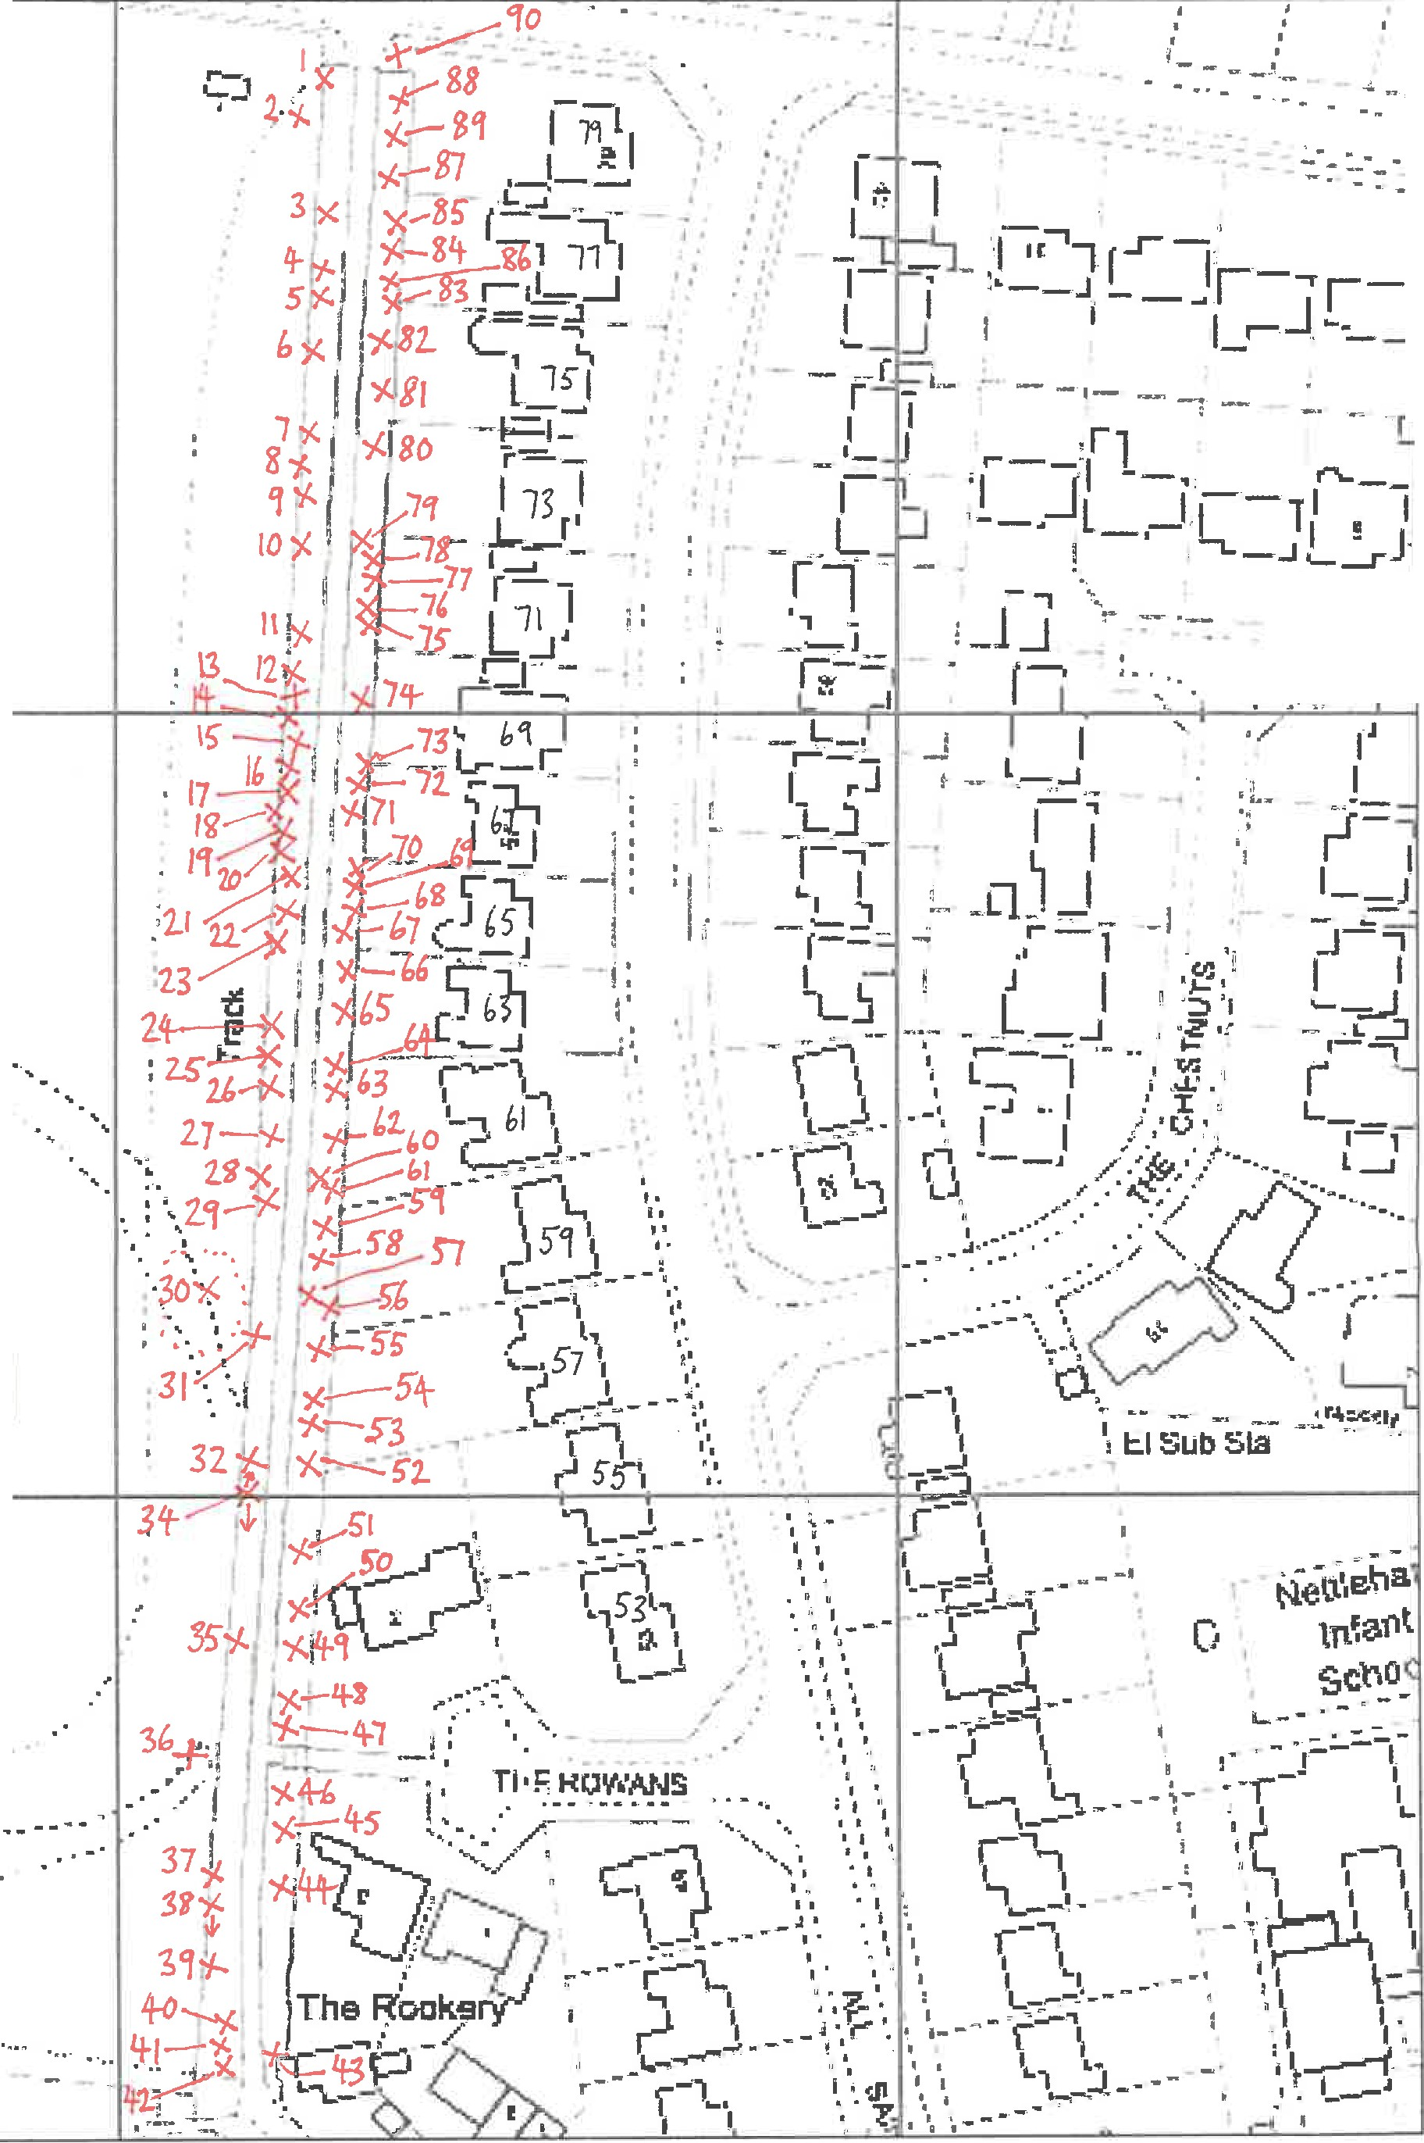
.....,.tit--:::...

.-- -.... - ---

leham

. - -

iJ.r..,... i,n,;,ir.
...uoi1C\JllLJU1L CONSVllM-lf

Nettleham, Green Lane
Tree survey
!st,15th & 19th May 2023

Tree Survey 1st, 15th & 19th May 2023 inspected by Sara Bright
Green Lane, Nettleham, Lincoln Sa, dght
ARBOR!CULTURAL CONSULTANT

Tree no | Size band | Soecles | Aaeclass | Condition | Notes | Work reauired | Priorltv
1 | S2 | Crataegus monogyna Hawthorn | mature | RatherPoor | old hedgerow/ boundary trees near the lane entrance - approx 1Orn, ivy clad stems, not being managed, poor structure, encroaching bridleway (BW) | sever ivy, pollard group at approx 1-1.2m to regenerate | winter
2 | S3 | Acer pseudoplatanus Svcamore | mature | Moderate | ivy clad tree on police land, low risk to PC | no action
3 | S4 | Acer platanoides Norway maple | mature | Moderate | ta11 0038, rather ooor form, some deadWood above BW | remove deadwood above BW | 3 months
4 | S4 | Fraxinus excelsior Ash | mature | Moderate | tag 0039, old hedgerow coppiced stems, 2 self-grafting - interesting feature, ivy on stems, minor deadwood | sever ivy, monitor for Ash dieback disease (ADD) | 3 months
5 | S4 | Acer platanoides Norway maple | mature | Moderate | tag 0040, rather poor form, some deadwood above BW | remove deadwood above BW | 3 months
6 | S4 | Acer platanoides Norway maple | mature | Moderate | taa 0041, rather ooor form, biforcates al 2m, some deadwood above BW | remove deadwood above BW | 3 months
7 | S4 | Acer platanoides Norway maple | mature | Moderate | tag 0042, adapted lean, rather poor form - poor pruning in past, some deadwood above BW | remove deadwood above BW | 3 months
8 | S2 | Crataegus monogyna Hawthorn | mature | Moderate | old boundary tree, one stem has been laid along hedge | suggest lay other stems to south to regenerate | winter
9 | S3 | Acer platanoides Norway maple | mature | Moderate | tag 0043, adapted lean, rather poor form - poor pruning in past, old pruning wound cavities  - one on stem to police field has bat potential, some deadwood above BW | remove deadwood above BW | 3 months
10 | S4 | Acer platanoides Norwav maple | mature | Moderate | tag 0044, rather poor form, Ivy on stem, some deadwood above BW | sever ivy, remove deadwood above BW | 3 months
11 | S4 | Fraxinus excelsior Ash | mature | Moderate | tag 0045, old hedgerow coppice -3 stems, one stem has old wound at 4m, ivy on stems, deadwood above BW | sever ivy, remove deadwood above BW, monitor for ADD | 3 months
12 | S4 | Acer platanoides Norway maple | mature | Moderate | tag 0046, adapted lean, poor pruning in past, small wound and decay at 2m, minor deadwood | no action
13 | S4 | Fraxinus excelsior Ash | mature | Moderate | tag 0047, 2 stems, some ivy on stems, minor deadwood | sever ivv, monitor for ADD | 3months
14 | S4 | Fraxinus excelsior Ash | mature | Moderate | tag 0048, has sub-stem, ivv on stems, tow target deadwood | sever ivy, monitor for ADD | 3 months
15 | S4 | Acer platanoides Norway maple | mature | Moderate | tag 0049, poor form - poor oruning in past, area of decay at 2m, minor deadwood | no action
16 | S4 | Fraxinus excelsior Ash | mature | Moderate | tag 0050, old hedgerow coppice -4 stems, 2 are self-grafting, some small stem cavities, ivy on stems, deadwood above BW | sever ivy, remove deadwood over 4cm 0 above BW, monitor for ADD | 3months
17 | S4 | Fraxinus excelsior  Ash | mature | Moderate | tag 0051, old hedgerow coppice - 3 stems, some small stem cavities, ivy on stems, deadwood above BW | sever ivy, remove deadwood over 4cm 0 above BW, monitor for ADD- • | 3 months
18 | S3 | Fraxinus excelsior Ash | mature | Moderate | tag 0052, old hedaerow coppice - 3 stems, ivy on stems, ooor form | monitor for"ADD | summer
19 | S4 | Acer platanoides Norway maple | mature | Moderate | tag 0053, minor deadwood -· | no action
20 | S4 | Acer platanoides Norway maple | mature | Moderate | taQ 0054, included union at 4m, minor deadwood and ivy | ..  no action ..
21 | S4 | Fraxinus excelsior Ash | mature | RatherPoor | tag 0056, 3 stems, some self-grafting of lower stems - interesting feature, some deadwood above BW | sever ivy, remove deadwood over 4cm 0 above BW, monitor for ADD | 3 months

22 | S3 | Acer platanoides Norwav maple | mature | Moderate | laQ 0055, deadwood above BW, woodchip pile against stem - bad practice | remove deadwood above BW, suggest move  woodchip and ensure piles are away from the trees in future | 3 months
23 | S3 | Acer platanoides Norway maple | mature | Moderate | tag 0057, deadwood above BW, woodchip pile against stem - bad practice | remove deadwood above BW, suggest move woodchip | 3 months
24 | S4 | Acer platanoides Norwav maple | mature | Moderate | taq 0058, deadwood above BW | remove deadwood above BW | 3 months
25 | S4 | Fraxinus excelsior Ash | mature | Moderate | iw clad stem; appears to be sound, minor deadwood, growina to west | sever ivy, monitor for ADD | 3 months
26 | S3 | Acer platanoides Norwav maple | mature | Moderate | taQ0059, ivv clad stem, dead Hawthorn stem leaning against tree | remove dead stem, sever ivy | 3months
27 | S4 | Fraxinus excelsior Ash | mature | Moderate | taa 0060, old hedgerow coppice - 4 stems, some ivy on stems, minor deadwood | sever ivy, monitor for ADD | 6 months
28 | S4 | Fraxinus excelsior Ash | mature | Moderate | taQ0061, twin-stemed, iw on stems, one dead branch to BW at aoorox 4m | remove dead branch at main stem, sever ivy, monitor for ADD | 3 months
29 | S4 | Acer platanoides Norway maple | mature | Moderate | tag 0062, old stem cavity at 1m, minor deadwood | no action
30 | S4 | mixed | mature | Moderate | group of trees in the police field near the boundary, including Sycamore and Ash with ivy clad stems; low risk to PC and BW | no action
31 | S4 | Acer platanoides Norway maple | mature | Moderate | tag 0063, some ivy on stem, area of vertical reaction growth up east side of stem, from base, old stem damage and cavity at 4.5m, some deadwood over BW | remove deadwood over 4cm 0 above BW, suooest annual inspection to monitor | 3 months
32 | S4 | Fraxinus excelsior Ash | mature | Moderate | tag 0064, group of 10 stems, growing co-<lependently, close to boundary, including old hedi:ierow coocice stool - interestinq feature, some low tarqet deadwood | no action
33 | S4 | Acer platanoides Norway maple | mature | Moderate | tag 0065, adapted lean, minor deadwood | no action
34 | S2 | Crataegus monogyna Hawthorn | over mature | RatherPoor | section of old boundarvhedQe, iw clad and dead stems, some rose qrowina throuah | sever ivy, suggest pollard or lay a few stems each winter for 3 or 4 years to regenerate | winter
35 | S4 | Fraxinus excelsior Ash | mature | Moderate | tag 0066, poor form - 3 main stems, deadwood above BW | remove deadwood over 4cm !2) above BW, monitor for ADD | 3 months
36 | S4 | Acer pseudoplatanus S1<Camore | mature | Moderate | ivv clad tree in police field, 2 lonQ low branches to BW | remove low Branches at boundary line to clear BW | 3 months
37 | S2 | Crataegus monogyna Hawthorn | mature | Poor | tree in old boundary hedge, ivy clad stems, has a living Ash stem hung up in crown - from an old failure from tree on police land | sever ivy, remove the crown of Ash tree from the Hawthorn - the increasing size and weight of Ash  will lead to failure of the Hawthorn | 3 months
38 | S2 | Crataegus monogyna Hawthorn | mature | RatherPoor | section of old boundary hedge, ivy clad and dead stems, southernmost stem is growing out to BW | sever ivy, prune back to clear BW, suggest pollard or lay a few stems each winter for 3 or 4  1 years to regenerate | winter
39 | S4 | Fraxinus excelsior Ash | mature | Moderate | tag 0067, group of 3 ivy clad stems, minor deadwood | sever ivy, monitor for ADD | 6 months
40 | S3 | Tilia species Lime | mature | Moderate | tag 0069, some ivyon stem, minor deadwood, some low branches to BW | remove lowest 2 branches to clear BW | 3 months
41 | S4 | Tilia species Lime | mature | Moderate | taQ0068, stem biforcates at 2m, minor deadwood, low branches to BW and sian | prune to clear BW by 4m, and to clear sign by1m | 3months
42 | S2 | Betula pendula Birch | mature | Moderate | minor deadwood, OHB's to street light | prune to clear liQht by 1m | 3 months
43 | S2 | Crataegus monogyna Red hawthorn | mature | Moderate | twin-stemmed, minor deadwood, OHB's to BW and gate | prune back by 1-2m at appropriate points to clear aate and Qive 4m BW clearance | 3 months

44 | S3 | Pnmus species | mature | RatherPoor | ivy on stem, some deadwood, thinnning crown, has been heavily oruned in oast | sever ivy, remove deadwood over 4cm (11 | 3 months
45 | S3 | Betula pendula Birch | mature | Moderate | slender, minor deadwood, old stem cavity at 2m | no action
46 | S1 | Corylus avellana Hazel | mature | Moderate | lqroup of 4 stools | suggest coppice stems at approx 0.3m to regenerate | winter
47 | S3 | Acer campestre Field mallle | mature | Moderate | tag 0070, biforcates at 1.5m, minor deadwood above BW, some epicormic growth | no action
48 | S4 | Acer campestre Field maple | mature | Moderate | tag 0071, stem cavity at 1.8m, some reaction growth on stem, minor deadwood, thin crown | no action
49 | S2 | Crataegus crus-galli Cockspur hawthorn | mature | Moderate | Ivy on stem, some deadwood | no action
50 | S4 | Fraxinus excelsior Ash | mature | Moderate | tao 0072, ooor form due to ooor prunino over manv vears, stem sound | monitor for ADD | summer
51 | S2 | Pyrus species Prunus species | mature | Moderate | old fallen tree now regenerating stem | no action
52 | S3 |  | mature | Moderate | taa 0073, stem biforcates at 2m, minor deadwood, healthy crown | no action
53 | S3 | Populus species | mature | Moderate | taq 0074, ivy on stem, has had top removed in past, stem sound | sever ivy | 6 months
54 | S4 | Acer platanoides Norway maple | mature | Moderate | tag 0075, appears to be in moderate condition but ivy clad stem, poor form from poor pruning in past, minor deadwood (nearby trees are regularly beinq 'toooed' by someone) | sever ivy, stop unnecessary pruning | 3 months
55 | S4 | Acer platanoides Norway maple | mature | Moderate | tag 0076, appears to be in moderate condition but ivy clad stem, poor form from poor IDnJning in past, minor deadwood (nearby trees are reQularlv beinQ'loaned' bv someone) | sever ivy, stop unnecessary orunina | 3 months
56 | S2 | Crataegus monogyna Hawthorn | mature | Poor | has had top removed, now 'lollipop' with dead ivy in crown, another ivy clad Hawthorn here Is leaning a inst the fence | sever ivy, remove dead parts of ivy and tree to clear fence | 3 months
57 | S2 | Crataegus monogyna Hawthorn | mature | RatherPoor | ivy clad slender stems, minor deadwood | sever ivy, pollard at approx 1.6m to regenerate before failure | 3 months
58 | S2 | Acer campestre Field maple | semi mature | Moderate | the Nettleham wishing tree' has items tied on with tight wire or string | suggest ask people to remove or adjust their items, use wool or rafia in future | 3 months
59 | S4 | Fraxinus excelsior Ash | mature | RatherPoor | tag 0077, now poor form due to poor pruning, minor deadwood, ivy on stem (the neighbour mav believe this tree is to be removed in future - this is not necessary) | sever ivy, monitor for ADD | 6 months
60 | S4 | Fraxinus excelsior Ash | mature | Moderate | tag 0078. old stem cavity from paor pruning at 1m, deadwood above BW | remove deadwood over 4cm (1j above BW, monitor for ADD | 3 months
61 | S4 | Fraxinus excelsior Ash | mature | Moderate | tag 0079, some small sub-stems with ADD, deadwood above BW, been pruned back from neiqhbour | monitor for ADD | summer
62 | S4 | Fraxinus excelsior Ash | mature | Moderate | 0080, some deadwood stubs from pruning, minor deadwood | monitor for ADD | summer
63 | S2 | Crataegus monogyna Hawthorn | mature | RatherPoor | group of trees/ stems near boundary, have been pollarded in past, now tall and slender, some dead stems | jpollard stems at marked paints | 6 months
64 | S3 | Fraxinus excelsior Ash | mature | Moderate | tag 0081, recent paor pruning, minor deadwood | monitor for ADD | 6 months
65 | S2 | Crataegus monogyna Hawthorn | mature | Poor | jgroup of unbalanced old stems | jpallard stems at marked paints | 3 months
66 | S2 | Crataegus monogyna Hawthorn | mature | Poor | group of ivy clad stems, growing to neighbour | severivyandre nsoect | 3 months

I

67 | S3 | Fraxinus excelsior Ash | mature | Moderate | tag 0082, interesting adapted lower stem form, some low target deadwood, old small stem cavity at 1.2m | monitor for ADD | summer
68 | S2 | Crataegus monogyna Hawthorn | mature | Poor | group of 4 trees/stems, crowing to neiohbour, an actionable nuisance | lpollard stems at marked points | 3months
69 | S2 | Crataegus monogyna Hawthorn | mature | RatherPoor | group of ivyclad stems, some OHB's to neighbour, minor deadwood | sever ivvand re-insoect | 3 months
70 | S2 | Elder | mature | Poor | self-set tree, iw clad, Qrowina to neighbour | fell to coppice | 3 months
71 | S2 | Crataegus monogyna Hawthorn | mature | Poor | Qroup of 3 ivv clad trees, poor form | sever ivy, pollard stems at marked points to reQenerate | 3 months
72 | S3 | Fraxinus excelsior Ash | mature | RatherPoor | tag 0083, 3 main stems, ivy clad, rather poor form, minor deadwood, OHB's to neighbour, IDOssible thin crown | sever ivy, re-inspect when nearby Hawthorn have been pollarded, monitor for ADD | 3 months
73 | S2 | Crataegus monogyna Hawthorn | mature | Moderate | has been oruned, nest box on stem | no action
74 | S2 | mixed | mature | Moderate | Igroup of trees including Field maple, Hawthorn and Hazel, some ivv clad stems | sever ivy on bigger trees - 6 months, coppice some Hazel to reQenerate | winter
75 | S4 | Fraxinus excelsior Ash | mature | Moderate | taQ0084, rather ooor form, weiaht to BW, some deadwood, ivvon stem | sever ivy, remove deadwood over 4cm {II above BW, monitor for ADD | 3 months
76 | S3 | Fraxinus excelsior Ash | mature | Moderate | tag 0085, recently 'pruned' to a pole, some regrowth | monitor for ADD | summer
77 | S4 | Fraxinus excelsior Ash | mature | Moderate | tag 0086, was twin stemmed; one stem removed leaving a decaying base, poor form due to p0or DflJnina in past, minor deadwood | monitor for ADD | summer
78 | S4 | Fraxinus excelsior Ash | mature | Moderate | tag 0087, stem is sound, poor pruning in past, some deadwood | remove deadwood over 4cm above BW, monitor for ADD | 3 months
79 | S2 | Crataegus monogyna Hawthorn | mature | Moderate | 1group of 5 trees, some iw clad stems | sever ivy | 6 months
80 | S2 | Crataegus monogyna Hawthorn | mature | Moderate | Igroup of 7 trees, some slender stems starting to fail, ivvclad stems | sever ivv, oollard all stems at approx 1.5m | 3 months
81 | S2 | Crataegus monogyna Hawthorn | mature | RatherPoor | ivy clad tree, has been pollarded | sever ivv | 3 months
82 | S4 | Acer platanoides Norway maple | mature | Moderate | taa 0088, ooor prunina in past, some deadwood stubs | no action
83 | S3 | Crataegus monogyna Hawthorn | mature | Poor | ivy clad tree, OHB's to neiohbour | IDOiiard at lop of fence height | 3 months
84 | S4 | Acer pseudoplatanus Svcamore | mature | Moderate | tag 0089, appears to be in moderate condition but ivy clad stem, high OHB's to neighbour. minor deadwood | sever ivv | 3 months
85 | S4 | Acer pseudoplatanus Svcamore | mature | Moderate | tag 0090, growing co-dependently with T84, ivy on stem, some epicormic growth, OHB's to neighbour - not an actionable nuisance but may be an issue to neighbour, minor deadwood | sever ivy | 6 months
86 | S2 | Crataegus monogyna Hawthorn | mature | Moderate | tree growing over neighbour, ivy clad stem | sever ivy, pollard at approx 1.5m if neighbour haoov for this to happen | 3 months
87 | S2 | mixed | mature | Moderate | qroup of Hawthorn, Hazel, Prunus, ivv on stems, some OHB's to BW | sever ivy, pollard Hawthorn and Blackthorn at 1-  1.5m to reaenerate and clear BW | 3 months
88 | S2 | Crataegus monogyna Hawthorn | over-mature | Poor | group of 3 ivy clad trees, poor form, one near BW entrance is growing with a Blackthorn, deadwood, starting to fail | sever ivy, pollard stems at marked points, unmarked stems at 1.2m | 3 months
89 | S4 | Acer pseudoplatanus Svcamore | mature | Moderate | taa 0091, iw on stem, some low target deadwood, OHB's to neiahbour - not actionable | sever ivy | 6 months

ox 1m -if PC owned 3 months
90
Prunus species
S1 Blackthorn
semi mature !Moderate
rouo of stems growing behind seat, OHB's to BW siQn and the hiQhwa

below: looking north along Green Lane below: tree with interesting form
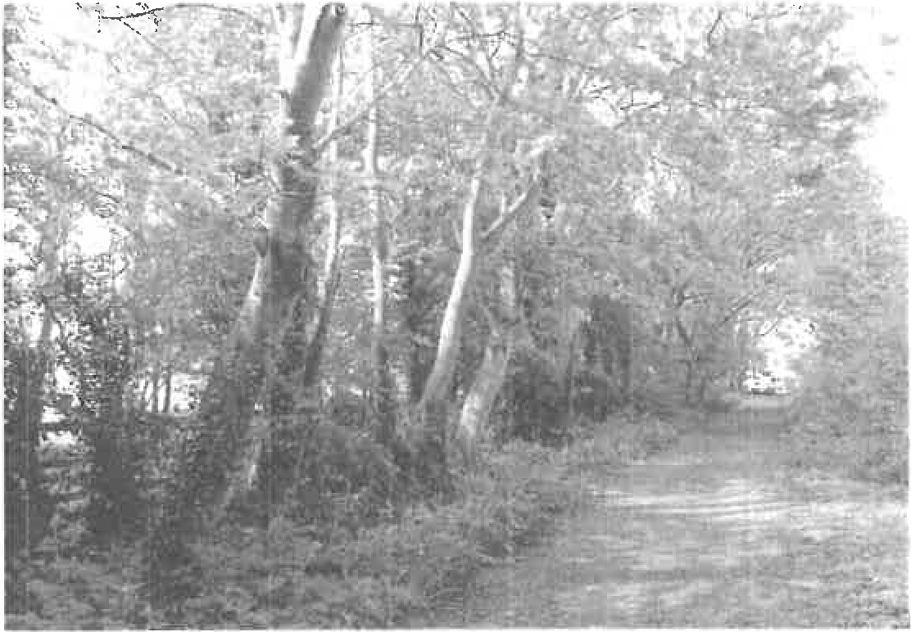
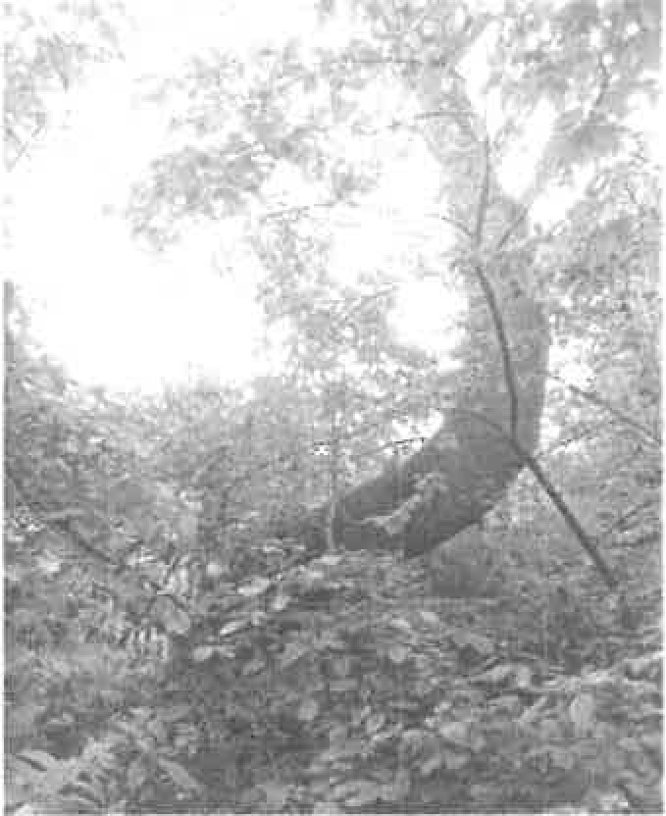

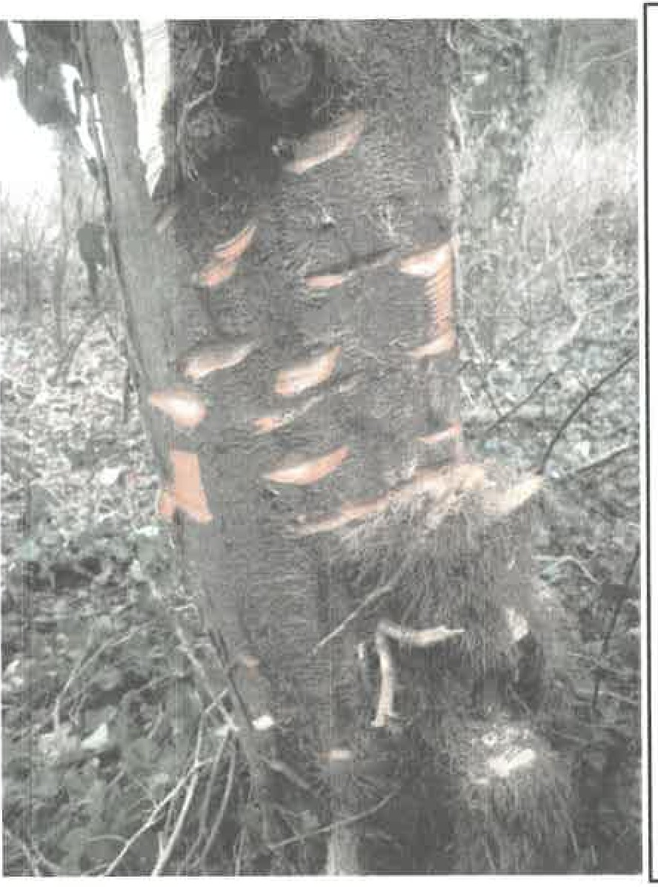
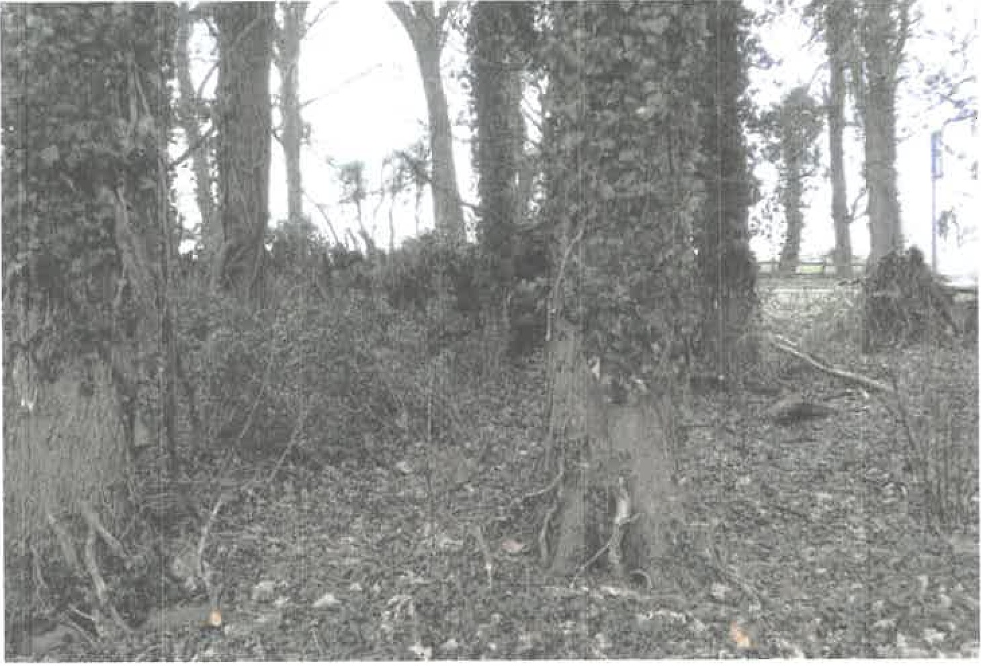
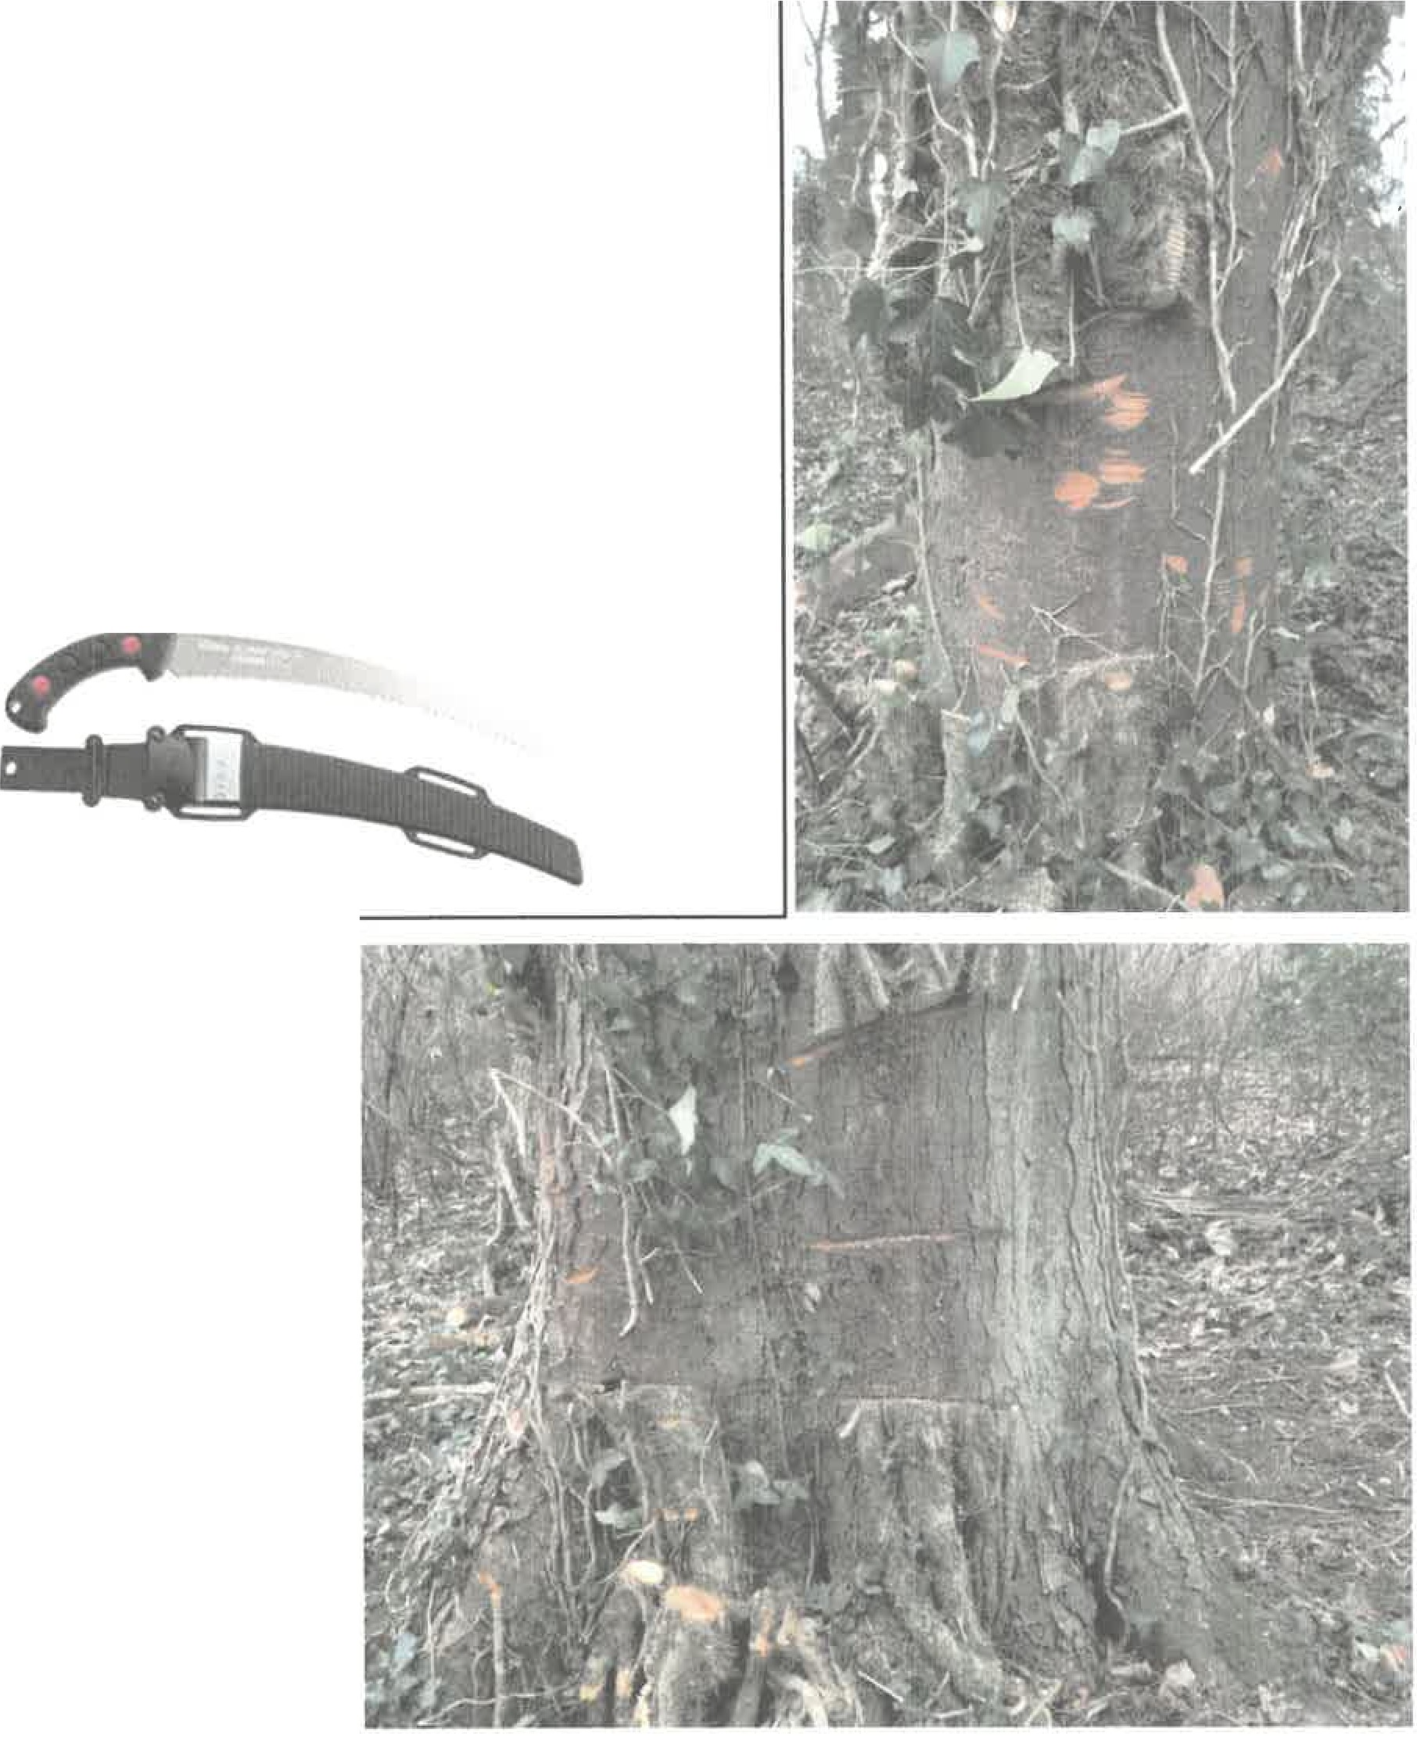
Poor ivy cutting -
Cutting ivy with a chainsaw like this is very damaging to the long term health of the tree. Extensive wounds to the bark allows various pathogens to easily enter the tree, or may effectively 'ring bark' the tree and lead to it dying.
If using a chainsaw the final cut should be made with a curved handsaw e.g. Silky Zubat.

