DONATED BENCH SEATS POLICY
- Nettleham Parish Council currently maintains around 55 benches (Sept 2021) many of which have been donated to the Council over many years and are in varying degrees of condition.

- Insurance cover for damage, loss or destruction of benches is included in the Council’s policy, although limited, as the insurers initial excess charge is currently set at £125.00 and is subject to change.

- Generally, the Council does not cover the cost to replace existing benches and does not generally accept requests to site additional benches – unless, following survey the need for a new bench is identified.

- A survey of all benches is generally carried out annually (usually between May - September) and the following action(s) will be taken by the Council, as identified - although our actions are subject to the availability of staff resources:
- General clean and paint treatment carried out where required;
- Identified repairs to be undertaken;
- Or if beyond repair or the cost to repair the bench is more that 50% of its replacement cost - see section 5 & 6 below

- The Council will not generally cover the cost to replace benches which are lost, damaged beyond repair or not within reasonable repair costs.
- In such circumstances, the donor of the seat will be notified and may be offered the opportunity to provide a replacement bench;
- The Council will also maintain a list of residents who have expressed an interest in donating a bench (in date order of receipt of their written request);
- Where it is not possible to contact the bench donor, the bench will be removed and disposed of - and the plaque retained at the Council Store for up to five years;
- In this event, the Property Committee may approve a replacement bench, from a new donor, (with full replacement costs being met at the new donor’s expense). Donor applications will be considered, in the date order received.
- The potential donor will be contacted and if they still wish to donate a bench the request will be included as a Property Committee agenda item, to seek approval.

- Any replacement bench needs to be agreed and approved by the Property Committee and will be provided, generally, in line with the following specification:

- Heavy Duty Recycled plastic or composite (incorporating sawdust) plastic fully assembled; ideally classic style with smoothly contoured scrolled arms; 100 x 50mm min. bullnose planks with heavy duty frame/legs/arm supports which can be galvanised/stainless steel with powder coat finish; colour brown/timber effect – support frame can be black; 4no. feet fixing brackets with associated screws and plugs for fixing to concrete - e.g. type similar to Type B in photograph shown overleaf.
- Heavy Duty Timber benches - hardwood and from sustainable sources (FCS Certified Hardwood) fully assembled: classic style with smoothly contoured scrolled arms with clear stain finish; 75mm thick min. material for arm and leg sections; 36mm thick min. rails – top rail 90mm for memorial plaque; 4no. feet fixing brackets with associated screws and plugs for fixing to concrete - e.g. type similar to Type A in photograph overleaf.

- Bench Size generally 1800mm long (although similar to one being replaced and to suit existing base) x 900mm min. high; Seat 500mm min. deep and backrest 420mm min high – height of seat from base to be 480mm.
- Memorial plaques to be brass and a maximum size of 150mm x 60mm with the maximum number of words being 15.
- The full cost for replacing the bench must be bourn by the donor. Following approval by Property Committee, the donor will be invoiced and payment must be received, in full, before the Council places the order for the replacement bench.

- Alternatively, if it is agreed that the donor can provide the bench, the Property Committee will need to approve the type, supplier, specification and timescales, prior to it being ordered and delivered to the bench site (or Council premises). The associated fixings will also need to be supplied by the donor. The bench will then be fixed in position by the Council.

- Once a seat has been installed it becomes the property of the Council. The Council then takes liability and responsibility for all maintenance requirements, in line with section 5 shown overleaf. No maintenance of any kind should be undertaken by the donor, their family or their representatives without prior agreement of the Council.
TYPICAL BENCHES
TYPE A - Hardwood (Heavy Duty) Bench
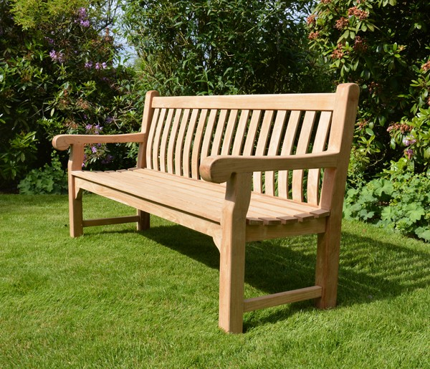

TYPE B - Recycled Plastic (Heavy Duty) Bench
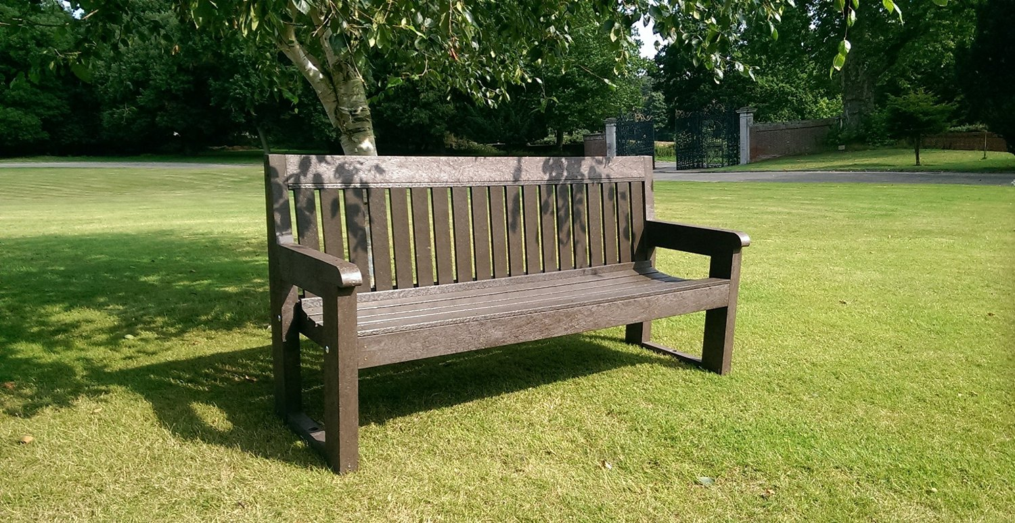

Approved & adopted at meeting of Nettleham Parish Council – 19.10.21 minute 146/21(a)

