NETTLEHAM PARISH COUNCIL

Nettleham Beck Management Plan
PART A: Nettleham Beck – Vision Statement
Nettleham Parish Council’s (NPC) Vision for the Nettleham Beck recognises it as a strategic asset in the attraction of, and character of, the village. In line with this, our vision for the Nettleham Beck seeks to guide both its strategic development over time and its day-to-day management.

Vision
To provide a safe, welcoming open space for the enjoyment of the community, highly valued for its opportunities for informal recreation, children's play, and for its contribution to Nettleham’s historic and natural heritage.
In meeting the aims and objectives for the policy, and in allocating residents’ precepts contribution towards this, we will seek to ensure that our activities:
- Maintain the Beck’s position as a key amenity feature within the village, a source of pride, which realises the full potential of its historic and natural attributes and ensure effective promotion of the Beck as a community resource.
- Retain awareness of riparian duties and obligations among village property holders on the Beck, providing advice, awareness and support from NPC where necessary.
- Positively welcome residents and visitors to Nettleham onto the Beck, in terms of both physical and social access.
- Ensure a healthy, safe and secure experience for residents and visitors.
- Provide a well-maintained and clean Beck environment, seeking to ensure that the landscape and infrastructure along the Beck’s riparian margins are free of litter.
- Seek to promote environmental quality and sustainable maintenance practices along the Beck’s margins by residents and the Parish Team.
- Enhance the biodiversity value of the Beck in line with Biodiversity Action Plan targets and local ecology, and maintain an up to date species and habitat record.
- Recognise, and where feasible, maintain the Beck’s historic landscape character whilst ensuring provision for contemporary users.

In delivering this vision we will seek to provide opportunities for increased community use and involvement, particularly through events, education, interpretation and building partnerships.
NPC will also ensure that all those involved in the management and maintenance of the Beck involve the local community are presented with information, consultation and input into its management.
PART B: NPC’S AIMS AND OBJECTIVES FOR THE MANAGEMENT OF THE BECK
Aims
- In so far as it is reasonably practicable for Nettleham Parish Council to do so, to alleviate the risks of the beck flooding residential and business premises.
- To protect and improve the native flora and fauna of the beck and its banks.
- To maintain the beck as a pleasant amenity.
- To interact with residents to increase their awareness, understanding, and participation.
These aims will inevitably sometimes conflict. Where possible, the Parish Council should seek a good compromise between the aims, but where they conflict, their priority is generally in the order given. However, in particular locations, such as near the village centre, aim [3] may take priority over aim [2]. The powers, duties and resources of the Parish Council are limited, so that most objectives require the willing participation of third parties, most notably the riparian owners and other statutory authorities.

Objectives for Aim 1
1a For each section of the beck, quantify the flood risks due to vegetation and silt, and formulate guidance for what control of these may be needed.
1b Communicate this guidance to those responsible by means of a management plan, and encourage and monitor adherence.
1c Evaluate what improvements to bridges and other obstructions, or to the basic channel depth and width, would reduce the flood risk in each section.
1d Make initial evaluations of the practicality of such improvements, and advocate the most cost-effective solutions to the relevant parties.

Objectives for Aim 2
2a For each section of the beck, record the existing flora and fauna to serve as a baseline for future improvement.
2b Suggest and evaluate schemes to improve biodiversity, seeking advice and help from expert sources.
2c Work with those concerned to agree and implement chosen schemes.
2d Monitor the results, and modify schemes accordingly.

Objectives for Aim 3
3a Keep those sections of the beck prioritised for amenity pleasant in appearance and safe for children to play in.
3b Keep all sections of the beck free of litter.

Objectives for Aim 4
4a Discuss and communicate with residents in general and riparian owners in particular how the beck can be improved.
4b Encourage riparian owners to co-ordinate their efforts within such an overall plan.
4c Encourage voluntary effort to help maintain, monitor and improve the beck.
4d Regularly publicise what is being done, and to invite feedback.

Enabling actions that will be key to achieving these objectives include:
- Establishing and documenting the legal framework surrounding maintenance of the beck and flood prevention.
- Assembling a library of key documents easily accessible to all concerned.
- As appropriate, making contact personally with all riparian owners, to discuss their views and communicate the Parish Council aims, and establish efficient communication links.
- Formulating and regularly updating the Council's management plan which will include regular inspections.
- Generating an overall plan to prioritise and implement actions to meet these objectives.

PART C: NPC – Beck Maintenance Policy

Introduction

Nettleham Beck, as well as being a natural watercourse, is a valued ‘Village Amenity’ particularly within the centre of the village.

NPC in accordance with the Nettleham Neighbourhood Plan and wider environmental issues undertakes a ‘watching brief’ and this policy outlines the action the Parish Council along with the support of residents, businesses and landowners who adjoin the beck (riparian owners) undertake on behalf of the village community as a whole.

- ‘S’ Bends to Washdyke Lane (Length B1 on attached plan NPC/01)
In addition to the inspections (by Parish Team) carried out following heavy rainfall and strong winds the Beck Working Group (BWG) will monitor the beck a minimum of once every three months and formally report back to the parish office. All work to be reported to the relevant riparian owners and also (if required) to Lincolnshire County Council as the responsible authority for action.

- Washdyke Lane to Police HQ boundary/1 Kingsway (Length B2 on attached plan NPC/01)
Washdyke culverts and weir downstream checked and cleared (by Parish Team) as appropriate following heavy rainfall and strong winds; Kingsway side (right bank) of beck to be maintained by NPC for amenity purposes as per the specification in Part D. Designated BWG member to inspect accessible lengths of the beck a minimum of once every three months and formally report back to the parish office.

- Police HQ boundary/ 1 Kingsway to Watermill Bridge (Length B3 on attached plan NPC/01)
Designated BWG member to inspect accessible lengths of the beck a minimum of once every three months and formally report back to the parish office.

- Watermill Bridge to Vicarage Lane (Length B4 on attached plan NPC/01)
Weirs and Watermill Bridge (Watermill Lane side), Church Street and Vicarage Lane culverts checked and cleared (by Parish Team) as appropriate following heavy rainfall and strong winds; this length of the beck is to be maintained by NPC as per the specification in Part D on ‘amenity grounds’ only. Designated BWG member to inspect accessible lengths of the beck a minimum of once every three months and formally report back to the parish office.

- Vicarage Lane to The Steepers (Length B5 on attached plan NPC/01)
Riverdale culvert checked and cleared (by Parish Team) as appropriate following heavy rainfall and strong winds; length of beck (highlighted red on attached plan NPC01 i.e. Riverdale open area – right bank and Village Hall boundary left bank as per the specification in Part D.

Designated BWG member to inspect accessible lengths of the beck a minimum of once every 3 months and formally report back to the parish office.

- The Steepers to Parish East Boundary (Length B6 on attached plan NPC/01)
Designated BWG member to inspect accessible lengths of the beck a minimum of once every 3 months and formally report back to the parish office. All work to be reported to the relevant riparian owners and also (if required) to Lincolnshire County Council as the responsible authority for action – i.e. no remedial work carried out or authorised by NPC.

Flood Protection:
This policy precludes any work associated with ‘flood protection’ other than clearing culverts and weirs of debris associated with heavy rainfall and/or strong winds as mentioned above – any other issues or substantial debris within the culverts to be reported immediately to Lincolnshire County Council as the responsible authority for action.

Note: Left and right banks are when facing downstream

Attachments – see Part E.
- Beck Plan NPC/01
- Responsibilities of riparian owners

PART D - Role of Parish Council: Outline Maintenance Specification
- Section B1 - “S” Bends to Washdyke Lane – Length adjacent to the “S” Bends (See attached Beck Plan NPC/01)

- Principal Objectives –
- Maintain to appropriate standard for amenity purposes.
- To ensure that the beck is clear of obstructions (including any fallen trees/branches) that may otherwise flow further downstream and thereby create a flood risk (in particular at the various culverts).

- Primary Responsibility - Riparian Owners with LCC Highways.

- Role of NPC – Monitoring & reporting.

- Specific Actions by NPC:
- Quarterly inspections by allocated BWG Member.
- Liaison with LCC Highways and Riparian Owners of any issues not addressed in a timely manner, as required.

- Section B2 – Length from Washdyke Lane to No 1 Kingsway/Police HQ boundary (See attached Beck Plan NPC/01)

- Principal Objective - Maintain an appropriate standard for amenity purpose (with such standard being determined by the Parish Council from time to time).

- Primary Responsibility –
1. NPC ref Right Bank &
2. Riparian Owners [Farmers] ref. Left Bank.

- Role of NPC – Monitoring & Maintenance of Right Bank (to the centre of the Beck).

- Specific Actions by NPC:
- Quarterly inspections by BWG Member.
- Removal of litter, fallen trees and branches, debris etc. by Parish Team as required. NB: Only in respect of Right Bank and to the centre of Beck.
- Cutting back of overhanging branches on Right Bank by Parish Team as required.
- Liaison with landowners [Farmer] of field on opposite side from the road as required.

- Section B3 – length from No 1 Kingsway/police HQ boundary to Watermill Bridge (see attached BECK Plan NPC/01)

- Principal Objective - Maintain an appropriate standard for amenity purpose (with such standard being determined by the Parish Council from time to time).

- Primary Responsibility - Riparian owners (Including in particular Lincs Police).

- Role of NPC - Monitoring only.

- Specific Actions by NPC:
- Quarterly inspections by BWG Member subject to Right of Access
- Inform riparian owners of any issues not addressed in a timely manner.

- Section B4 – Length from Watermill Bridge to Vicarage Lane (see attached BECK plan NPC /01)

- Principal Objective - Maintain to an appropriate standard for amenity purposes (with such standard being determined by the Parish Council from time to time)

- Primary Responsibility –
- NPC: In respect of the bed and channel of the BECK only and
- The riparian owners in respect of all other aspects (including maintenance of the adjacent walls/banks /pathways and the cutting back of any overhanging branches)

- Role of NPC –
- Monitoring of the entire section
- Maintenance of the bed & channel of the BECK itself and
- Upkeep of the weirs (as per EA Impounding Licenses) outside the Church.

- Specific Actions by NPC -
- Fortnightly inspections by Parish Team.
- Quarterly inspections by BWG Member.
- Removal of litter, fallen trees/branches, debris etc. within the channel, by staff as required.
- Liaison with riparian owners (including Lincolnshire CC Highways) as required.
- Maintenance and removal of the 3 weirs along this section of the Beck in accordance with the terms of the Impounding Licenses granted by the predecessor in title to the Environment Agency (dated 16 July 1991 & 3 August 1994).

- SECTIONS B5 & B6: VICARAGE LANE – VIA THE STEEPER TO PARISH EAST BOUNDARY (see attached Beck Plan NPC/01)

- Principle Objective - To ensure a good flow of water and thereby minimise the risk of flooding in the village

- Primary Responsibility - NPC at Riverdale, Riparian Owners, LCC Highways and Anglian Water

- Role of NPC – Monitoring only

- Specific Actions of NPC
- Checking culverts are clear/not blocked on Brookfield Avenue.
- Removing rubbish or anything that is to the detriment of the Beck.
- Liaison with Riparian Owners; LCC Highways, and Anglian Water if required through Facilities Manager.
- Inspected every 3 months, by designated BWG Member.

PART E: MISCELLANEOUS DOCUMENTATION

Beck Plan NPC/01
KEY:

B1 ‘S’ Bends - Washdyke Lane

B2 Washdyke Lane - 1 Kingsway/Police HQ Boundary

B3 1 Kingsway/Police HQ Boundary - Watermill Lane

B4 Watermill Bridge - Vicarage Lane

B5 Vicarage Lane - The Steepers
(inc. Riverdale Right Bank & Village Hall Left Bank)
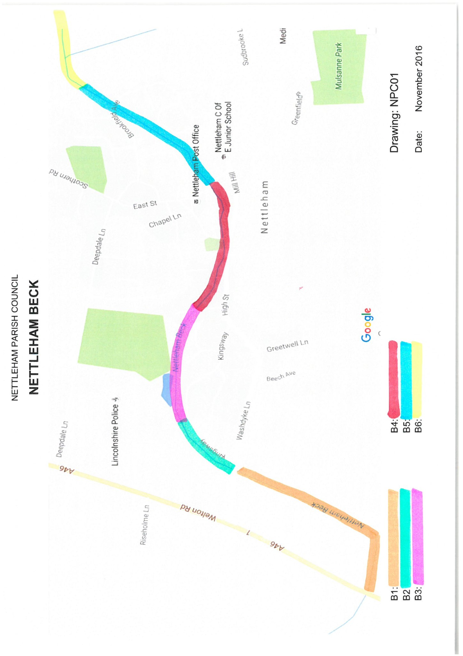
B6 The Steepers - Parish East Boundary

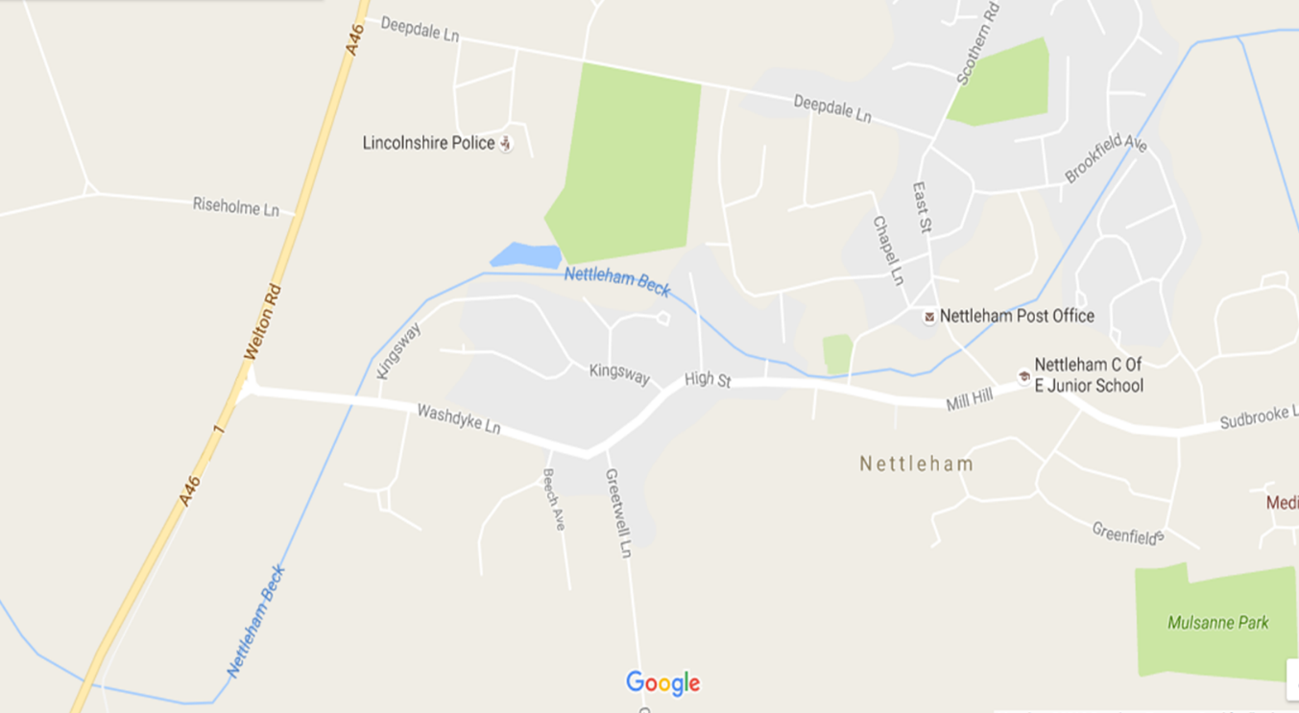

RESPONSIBILITIES OF RIPARIAN OWNERS

- LIVING NEXT TO THE NETTLEHAM BECK
The Beck running through Nettleham Parish is designated as an 'ordinary watercourse'. If you own the land bordering an ordinary watercourse, you have certain rights and responsibilities established in common law for many years. In legal terms you are a ‘riparian owner’.

- YOUR RESPONSIBILITIES AS A RIPARIAN OWNER
As a riparian owner you have responsibilities in relation to the watercourse flowing through or adjacent to your property. Your legal duties are to:
- Pass on the flow without obstruction, pollution or diversion affecting the rights of others.
- Accept flood flows through your land, even if caused by inadequate capacity downstream, as there is no common law duty to improve a watercourse.
- Maintain the bed and banks of the watercourse (including trees and shrubs growing on the banks), and for clearing any debris, natural or otherwise, including litter and animal carcasses, even if it did not originate from your land.
- Not cause any obstructions to the free passage of fish.
- Keep the bed and banks clear of any matter that could cause an obstruction, either on your land or by being washed away by high flow to obstruct a structure downstream. The Beck and its banks should not be used for the disposal of any form of garden or other waste.
- Keep clear any structures that you own such as culverts, trash screens, weirs and mill gates.
- Protect your property from seepage through natural or man-made banks. You may have flood defences such as walls and embankments on your property, which are vital for the protection of both yourself and others. You should in the first instance discuss the maintenance of such defences with the Parish Council if you have any concerns relating to these.
These are some but not all of your responsibilities, and failure to carry these out could result in possible civil action from others.
Your responsibilities as a riparian owner are also based on the following legislation:
- Flood and Water Management Act 2010
- The Land Drainage Acts of 1991 & 1994
- Water Resources Act 1991
- The Environment Agency (EA) Land Drainage byelaws
- The Public Health Act 1936

- YOUR RIGHTS AS A RIPARIAN OWNER
As a riparian owner:
- You are presumed to own the land up to the centre of the watercourse, unless it is known to be owned by others.
- You have the right to receive flow of water in its natural state, without undue interference in quantity or quality.
- You have the right to protect your property from flooding, and your land from erosion. You may need the consent of Lincolnshire County Council or the Environment Agency for such works.
- You have the right to fish in your watercourse, but this must be by legal methods and with a valid EA rod licence.
- Without needing a licence, you can abstract a maximum of 20 cubic metres of water per day for the domestic purposes of your own household or for agricultural use, excluding spray irrigation; from a watercourse at a point that directly adjoins your land. Most other types of abstraction will require a licence from the Environment Agency.
Before starting any work on or adjacent to a watercourse, you must submit plans to Lincolnshire County Council to determine whether you require their consent or that of other authorities. You may also require planning permission. The Local Planning Authority would be happy to advise on such matters.

- WHAT IS NETTLEHAM PARISH COUNCIL RESPONSIBLE FOR?
Whilst riparian owners are responsible for maintaining watercourses, Nettleham Parish Council takes an active interest in the amenity value of the Beck to the community, its water quality and environmental status. It carries out an inspection of the Beck on a regular basis to identify issues or risks that threaten its contribution to the wider community of Nettleham and its wellbeing. The Parish Council reserves the right to take action where the condition of the Beck is such that it is likely to increase flood risk and loss of amenity.

